**CURRICULUM VITAE**

**2016**

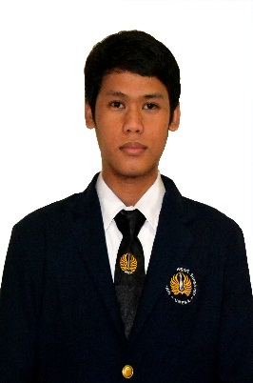

MOKHAMAD ARIADI, A.Md

Hard Worker, Good Listener, Postive Attitude, Flexible

**Contact & Portofolio**

**Personal Information**

**Address**

Jl. Jetis Kulon Gg 6 Wonokromo Surabaya

**Phone**

+6285895986529

**E-mail**

[mokhamad27@gmail.com](mailto:mokhamad27@gmail.com)

**Linkedin**

<https://www.linkedin.com/in/mokhamad-ariadi-59ab53b0>

**GitHub**

<https://github.com/addeye>

**Place, Date of Birth**

Bontang, 27 January 1993

**Gendre**

Male

**Nationality**

Indonesia

**Height**

167 cm

**Weight**

50 kg

**Status**

Single

**Language**

Indonesian

English

**Skills**

PHP- HTML-CSS-Jquery

Wordpress

Framework Laravel, Codeigniter

Adobe Photoshop

Corel Draw

**Responsible**

|  |  |  |  |  |  |  |  |  |  |
| --- | --- | --- | --- | --- | --- | --- | --- | --- | --- |
|  |  |  |  |  |  |  |  |  |  |

**Team Work**

|  |  |  |  |  |  |  |  |  |  |
| --- | --- | --- | --- | --- | --- | --- | --- | --- | --- |
|  |  |  |  |  |  |  |  |  |  |

**Creative**

|  |  |  |  |  |  |  |  |  |  |
| --- | --- | --- | --- | --- | --- | --- | --- | --- | --- |
|  |  |  |  |  |  |  |  |  |  |

**Learn New Things**

|  |  |  |  |  |  |  |  |  |  |
| --- | --- | --- | --- | --- | --- | --- | --- | --- | --- |
|  |  |  |  |  |  |  |  |  |  |

**Fajar Media**

**Jombang**

Jan 2014 -Mar 2015

(Freelance Programmer)

**Ashalta (Inovasi Teknologi Sejahtera) Surabaya**

Mar 2015 – Feb 2016

(Full-Stack Developer)

University State of Surabaya

Graduated D3 Informatics Management on Maret 2015

GPA: 3.40 Scale of 4.00

**Former Student of**

SMA Negeri Mojoagung (2007 to 2010)

SMPN 2 Mojoagung (2004 to 2007)

SDN 1 Dukuhmojo Mojoagung (1998 to 2004)

**Education**

**Experience**